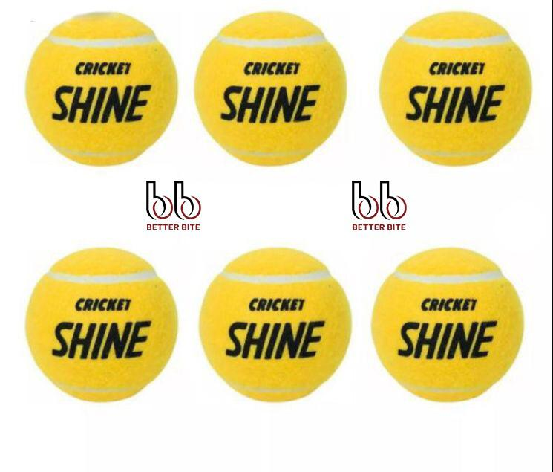Pack Of 6 Shine Tennis Cricket Ball Tape Balls Good Quality

Rs. 499

~~Rs. 1,599~~-69%

* Premium Quality
* Type: Tennis Ball
* For All Surfaces
* Consistent Feel
* Durable
* Reduce Shock
* Premium Quality
* Type: Tennis Ball
* For All Surfaces
* Consistent Feel
* Durable
* Reduce Shock
* Premium Quality
* Type: Tennis Ball
* For All Surfaces
* Consistent Feel
* Durable